***Software Testing Assignment-2***

***Module–2(Manual Testing)***

**(1) What is traceability matrix?**

* Mapping of the requirements with the TC – RTM.

**(2) What is Boundary value testing?**

* The method refines the EP method, where we can just analyze the boundary to get the valid range.

**(3) What is component testing?**

* Testing performed to expose defects in the interfaces and interaction between integrated components.

**(4) What is Equivalence partitioning testing?**

* Aim is to treat groups of inputs as equivalent and to select one representative input to test them all.

**(5) What is functional system testing?**

* Testing the attributes of the system that are directly a effected to the functionalities of the system.

**(6) What is Non-Functional Testing?**

* Testing the attributes of the system that are not directly affected to the functionalities of the system.

**(7) What is Adhoc testing?**

* Adhoc testing is an informal testing type with an aim to break the system.
* Main aim of this testing is to ﬁnd defects by random

checking.

**(8) What is Integration testing?**

* Integration Testing is a level of the software testing process where individual units are combined and tested as a group.

**(9) What is white box testing and list the types of white**

**box testing?**

* White Box Testing: Testing based on an analysis of the

internal structure of the component or system.

* Also known as Glass box testing or Open box testing
* There are three types of white box testing .

(a) Statement coverage

(b) Decision coverage

(c) Condition coverage

**(10) Mention what bigbang testing is?**

* In Big Bang integration testing all components or modules is integrated simultaneously, after which everything is tested as a whole.

**(11) What is the purpose of exit criteria?**

* Everything must be completed before testing can be concluded.

**(12) What is black box testing? What are the different**

**black box testing techniques?**

* The technique of testing without having any knowledge of the interior workings of the application is Black Box testing.
* Directly executing the executable code without source code.
* There are four Techniques of white box testing .

(a) Equivalent Partitioning

(b) Boundry Value Analysis

(c) Decision Table

(d) State Transition Technique

**(13) What is Error, Defect, Bug and failure?**

* Error :

mistake in coding

Defect :

Error found by the tester.

Bug :

Defect accepted by the developer.

Failure :

Build does not meet the requirements.

**(14) What is 7 key principles? Explain in detail?**

* 7 key principles of testing

**(1) Testing shows presence of Defects**

* Testing can show that defects are present, but cannot prove that there are no defects.

**(2) Exhaustive Testing is Impossible**

* Testing everything including all combinations of input and preconditions is not possible.

**(3) Early Testing**

* Testing activities should start as early as possible in the

Software or system development life cycle and should

be focused on deﬁned objectives.

**(4) Defect Clustering**

* Defects are not evenly spread in a system if they are not clustered.

**(5) Pesticide Paradox**

* If the same tests are repeated over and over again, eventually the same set of test cases will no longer ﬁnd any new defects.

**(6) Testing is Context Dependent**

* Testing is done diﬀerently in diﬀerent contexts.

**(7) Absence of Errors Fallacy**

* Even after defects have been resolved it may still be unusable or does not fulﬁl the users’ needs and expectations

**(15) What determines the level of risk?**

* A factor that could result in future negative consequences.
* There are two types of risk

**(1) Project Risk**

Can be arised before manufacturing of the product.

**(2) Product Risk**

Can be arised after manufacturing of the product.

**(16) Difference between QA v/s QC v/s Tester**

|  |  |  |  |  |
| --- | --- | --- | --- | --- |
| **SR.NO** | **QA** | **SR.NO** | **QC** | **TESTING** |
| 1 | Process oriented activities. | 1 | Product oriented activities | Product oriented activities. |
| 2 | Preventive activities. | 2 | It is a corrective process. | It is preventive process |
| 3 | It is part of SDLC. | 3 | It is part of STLC. | Testing is the subset of quality control. |

**(17) Difference between Smoke and Sanity?**

|  |  |  |  |
| --- | --- | --- | --- |
| **SR.NO** | **SMOKE** | **SR.NO** | **SANITY** |
| 1 | After receiving software build, smoke testing will be performed to check the critical functionalities of the app. | 1 | After receiving software build, with minor changes in code, or functionality sanity testing is performed to check that the bugs have been fixed and no further issues are introduced due to these changes. |
| 2 | To check the stability of the application. | 2 | To check the rationality of the application. |
| 3 | This testing is performed by the developers or testers. | 3 | This check the is usually performed by testers. |
| 4 | Smoke testing is a subset of acceptance testing. | 4 | Sanity testing is usually not documented. |
| 5 | Smoke testing is usually documented or scripted. | 5 | Sanity testing is a subset of regression testing. |
|  |  |  |  |

**(18) Difference between verification and Validation**

|  |  |  |  |
| --- | --- | --- | --- |
| **SR.NO** | **VERIFICATION** | **SR.NO** | **VALIDATION** |
| 1 | Verification is a process which is performed at development level. | 1 | Verification is a process which is performed at testing level. |
| 2 | It is process of evaluating product of development to check whether the specified requirements meet or not. | 2 | It is process of evaluating product of development to check whether it satisfied business requirements or not. |
| 3 | Verification can be achieved by asking “Are you building a product right?” | 3 | Validation can be achieved by asking “Are you building a right product?” |
| 4 | The evaluation of verification can be achieved by planning, Requirement specification, Design  Specification, Code specification, and test cases. | 4 | The evaluation of validation can be achieved as an actual product. |
| 5 | Verification activities are Reviews and Inspections. | 5 | Validation activity is Testing. |

**(19)** **What is Exploratory Testing?**

* Exploratory testing is a concurrent process where Test design, execution and logging happen simultaneously Explore the app features and in un-structured method, finds the defect.

**(20) What is Alpha testing ?**

* Alpha testing is definitely performed and carried out at the developing organizations location with the involvement of developers.

Alpha testing is not open to the market and public it is

always performed within the organization.

**(21) What is beta testing ?**

* It is always performed by the customers at their own site. It is only performed by independent testing team.

Beta testing is always open to the market and public.

**(22) When should "Regression Testing" be performed?**

* To test all the testcases whether they are possitive or negative.

Like there is some change in code for the previous build

like insert, delete or updating any functionality or bug

fixing should not affect the current functionalities.

Test cases are need to be rechecked repeatedly.

**(23) What is GUI Testing?**

* To check the graphical user interface by look and feel of the app.

GUI testing involves checking the screens with the controls

like menus, buttons, icons, and all types of bars – tool bar,

menu bar, dialog boxes and windows etc.

**Example:-**

- Check all the GUI elements for size, position, width, length and

acceptance of characters or numbers. For instance, you must

be able to provide inputs to the input ﬁelds.

- Check Font used in application is readable

- Check the alignent of the text is proper

**(24) What is load testing?**

* Load testing determines the behavior of the application when multiple users use it at the same time. It is the response of the system measured under varying load conditions.

The load testing is carried out for normal and extreme load

conditions.

**(25) What is stress Testing?**

* It even tests beyond the normal operating point and evaluates how the system works under those extreme

conditions.

Stress Testing is done to make sure that the system would

not crash under crunch situations.

Stress testing is also known as endurance testing.

**(26) Explain types of Performance testing.**

* There are 6 Types of Performance Testing.

**(1)** **Load Testing**

* Load testing determines the behavior of the application when multiple users use it at the same time. It is the response of the system measured under varying load conditions.

**(2) Stress Testing**

* It even tests beyond the normal operating point and evaluates how the system works under those extreme

conditions.

**(3) Scalability Testing**

* Scalability testing assesses a system's ability to handle increasing loads and maintain performance, ensuring it can accommodate growth in user traffic or data volume. It's a type of load testing that focuses on how the system scales up or down under varying conditions.

**(4) Volume Testing**

* Volume testing, also known as flood testing, is a type of non-functional testing that assesses how a system performs when exposed to large volumes of data, ensuring it can handle expected loads without performance degradation or instability.

**(5) Endurance Testing**

* Endurance testing, also known as soak testing, is a type of performance testing that evaluates how a system performs under sustained load over an extended period, simulating real-world usage to identify potential issues like memory leaks or performance degradation.

**(6) Spike Testing**

* Spike testing is a performance testing method that simulates sudden, extreme increases or decreases in load (traffic) to assess how a system reacts to these abrupt changes, identifying potential bottlenecks and ensuring stability during peak periods.

**(27) Difference between Priority and Severity**

|  |  |  |  |
| --- | --- | --- | --- |
| Sn no | Priority | Sn no | Severity |
| 1 | Severity is a parameter to denote the impact of a particular defect on the software. | 1 | Priority is a parameter to decide the order in which defects should be fixed. |
| 2 | Severity is related to the quality standard. | 2 | Priority is related to scheduling to resolve the problem. |
| 3 | Severity is divided into 4 categories:   * Critical * Major * Medium * Low | 3 | Priority is divided into 3 categories:   * Low * Medium * High |
| 4 | The testing engineer decides the severity level of the defect. | 4 | The product manager decides the priorities of defects. |
| 5 | Its value is objective. | 5 | Its value is subjective. |
| 6 | It indicates the seriousness of the bug in the product functionality. | 6 | It indicates how soon the bug should be fixed. |

**(28) What is Bug Life Cycle?**

The duration or timespan between the first time defect found and the time when defect closed, rejected, differed or postponed is called defect life cycle.

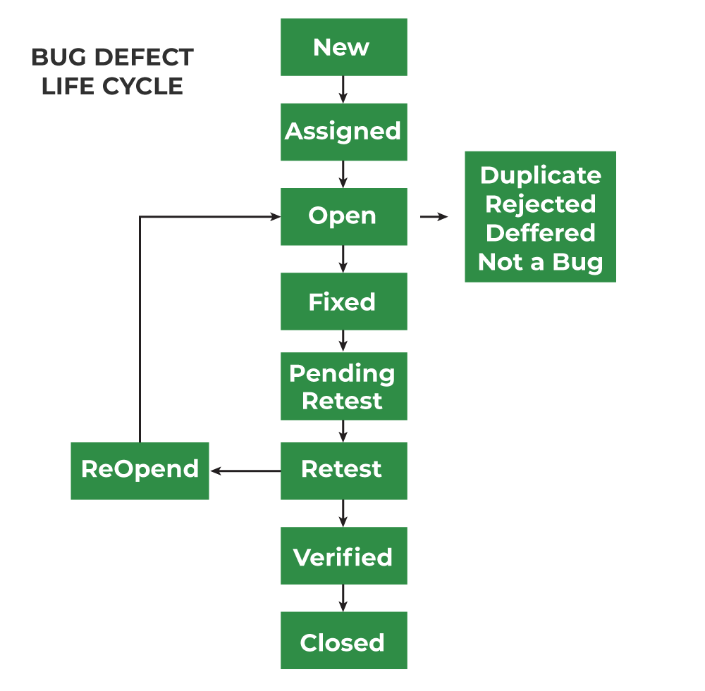

**(29) What is the difference between test scenarios, test**

**script?**

|  |  |  |  |
| --- | --- | --- | --- |
| **Sr.no** | **scenarios** | **test cases** | **test script** |
| 1 | A test scenario is a high-level document that describes end-to-end functionality to be tested. | Test Case is a step by step procedure to test any functionality of the software product. | Test Script is set of instructions or a short program to test any functionality of software product. |
| 2 | Test scenarios are focused on what to test. | Test Case is a manual approach of software testing. | Test Script is an automatic approach of software testing. |
| 3 | Test scenarios can be ambiguous as these are one-liners. | Test Cases are written manually. | Test Scripting is done by scripting format. |
| 4 | It will take less time as compared to test cases. | Test Case is used in manual testing environment. | Test Script is used in automatic testing environment. |
| 5 | It will take less time as compared to test cases. | Requires more resources and time. | Requires less time for testing scripts. |

**(30) Explain what Test Plan is? What is the information**

**that should be covered.**

* A test plan is a document detailing the objectives, resources, and processes for a specification test session for a software or hardware product. The plan typically contains a detailed understanding of the eventual workflow.

**(31) What is the difference between the STLC (Software**

**Testing Life Cycle) and SDLC ( Software**

**Development Life Cycle ) ?**

|  |  |  |
| --- | --- | --- |
| **SN.NO** | **STLC** | **SDLC** |
| 1 | SDLC is mainly related to software development. | STLC is mainly related to software testing. |
| 2 | Besides development other phases like testing is also included. | It focuses only on testing the software. |
| 3 | SDLC involves total six phases or steps. | STLC involves only five phases or steps. |
| 4 | In SDLC, more number of members (developers) are required for the whole process. | In STLC, less number of members (testers) are needed. |
| 5 | In SDLC, development team makes the plans and designs based on the requirements. | In STLC, testing team(Test Lead or Test Architect) makes the plans and designs. |
| 6 | It helps in developing good quality software. | It helps in making the software defects free. |
| 7 | SDLC phases are completed before the STLC phases. | STLC phases are performed after SDLC phases. |
| 8 | Post deployment support , enhancement , and update are to be included if necessary. | Regression tests are run by QA team to check deployed maintenance code and maintains test cases and automated scripts. |